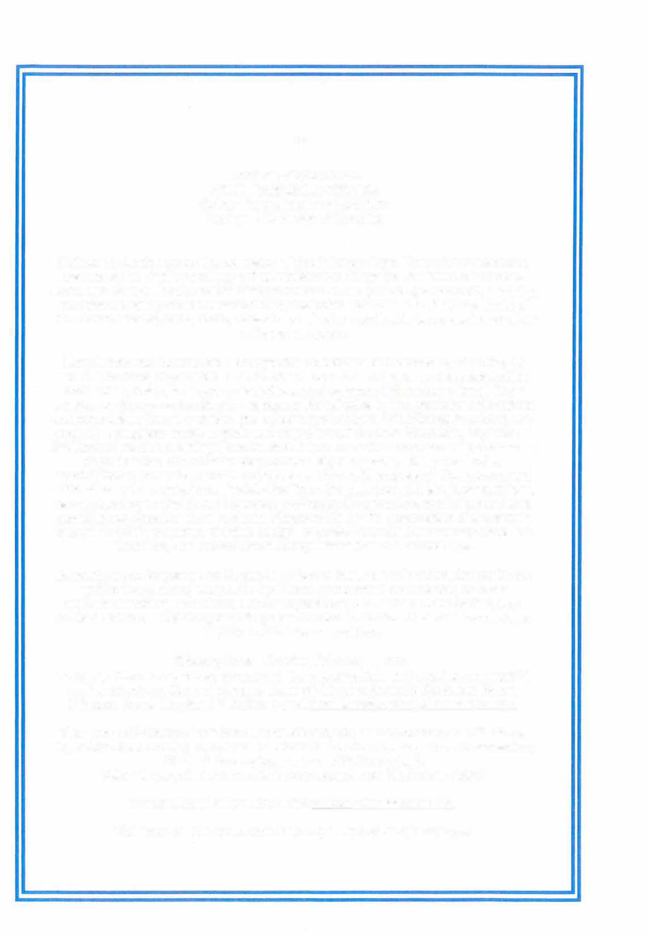

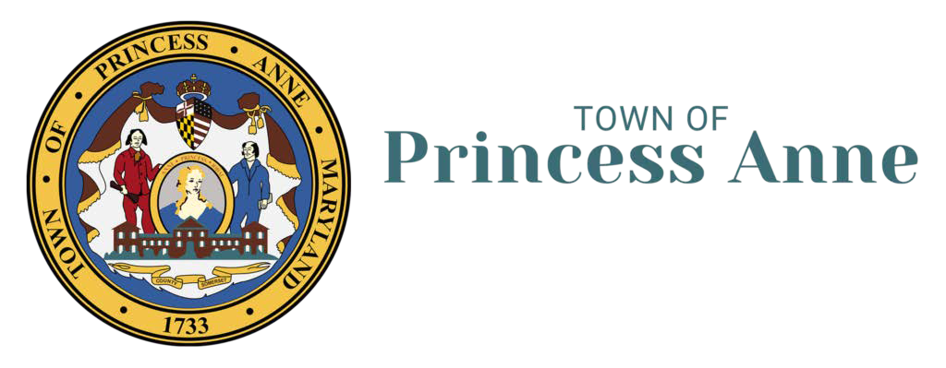
Town of Princess Anne

TOWN MANAGER POSITION
Salary Range: begins at $80,000 Exempt, Full Range of Benefits

Duties: Under the general supervision of the Princess Anne Town Commissioners, serves as the chief operating and administrative officer for the Town of Princess Anne, and directs the operation of departments within general government, assuring compliance with policies established by the Town Commission within the limits of the Town's charter, code, state, federal and all other applicable laws; performs other duties as assigned.
Requirements: Directs and manages the operations of the Town by directing all Town functions; Supervises all subordinate department heads and administrative staff. Hires, trains, evaluates, disciplines, and oversees this process for all Town employees through subordinate managers; Participates in the resolution of inquiries and complaints from the public, and other organizations; Establishes, monitors, and evaluates progress towards goals and objectives of the administration; Represents the Town at various meetings, serves as a liaison to various civic and/or government organizations and committees; Confers regularly with officials from other municipalities, counties, school boards, Main Street, Chambers of Commerce, and authorities and commissions; Assists the Town Commission with strategic and long­ range planning for the Town; Oversees professional contractors and/or consultants providing services for Town projects; Responsible for the preparation of the annual budget and GIP; prepares, reviews budget requests from all Town departments and functions, and schedules all budget meetings and workshops.
Education and Experience: Degree in public or business administration preferred; and/or two years of executive-level/local government experience; or other equivalent training, education, and/or experience; and a Valid State of Maryland Driver's License. Residency or willingness to relocate to the Town of Princess Anne is preferred but not mandatory.
Closing Date: March 9, 2026
To Apply: Send cover letter, completed Town application, and detailed resume/CV, to: President and Commissioners, Town of Princess Anne 30489 Broad Street, Princess Anne, Maryland 21853 or e-mail lhayward@townofprincessannemd.gov
The Town of Princess Anne has a Population 3,200, and is located on U.S. Route 13, in Somerset County, Maryland. The Town has a five-member Town Commission; 24 full-time employees; and a $3.1M budget.
Salary is negotiable dependent upon experience. Start date: ASAP For additional information, visit townofprincessanne.org.
The Town of Princess Anne is an Equal Opportunity Employer.

